**IFT 166 Introduction to Internet Networking**

**Lab 15  
Router Address Configuration**

For all parts of the lab, assume all switches are layer 2 switches (unmanaged switches)

**Part A: IP Configuration**

For each of the computers A, B, C, D and E assign an IP address, a subnet mask, and a default gateway.  
  
By understanding the Router’s IP address and Subnet Mask, you should be able to configure the PCs on the networks. A PC can sometimes can get their configuration details from multiple routers.

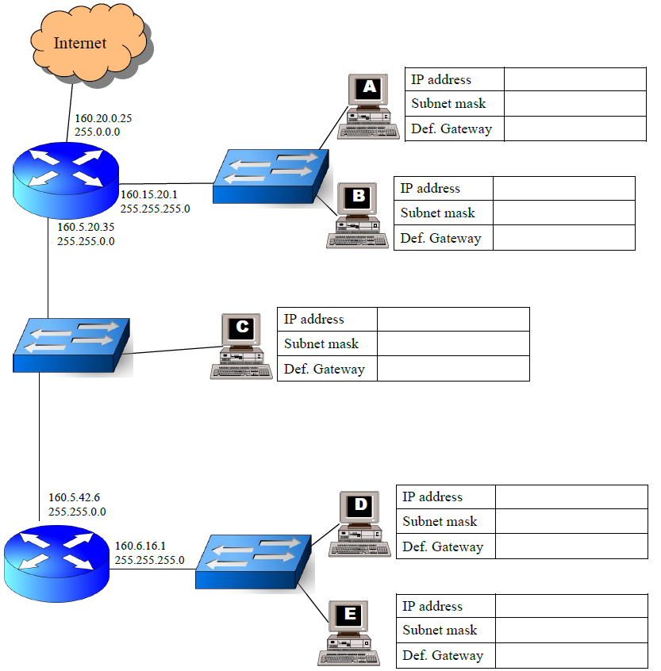

Assign an IP address, subnet mask, default gateway and DNS server address to Your PC in the following network:

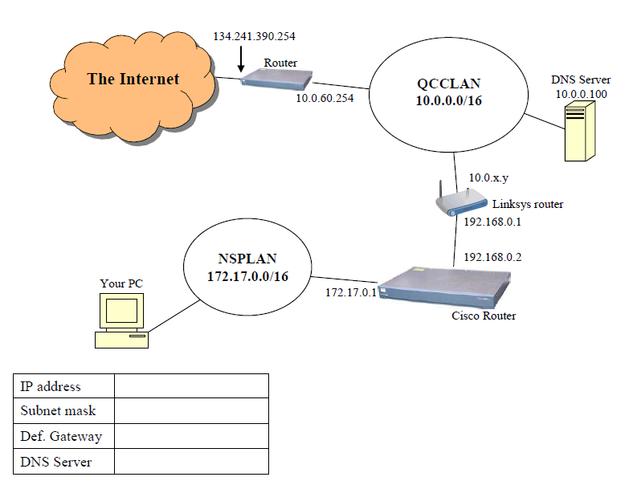

Assign a valid IP address, SM, DG, and DNS server address to PC1, PC2, and PC3 in the following network:

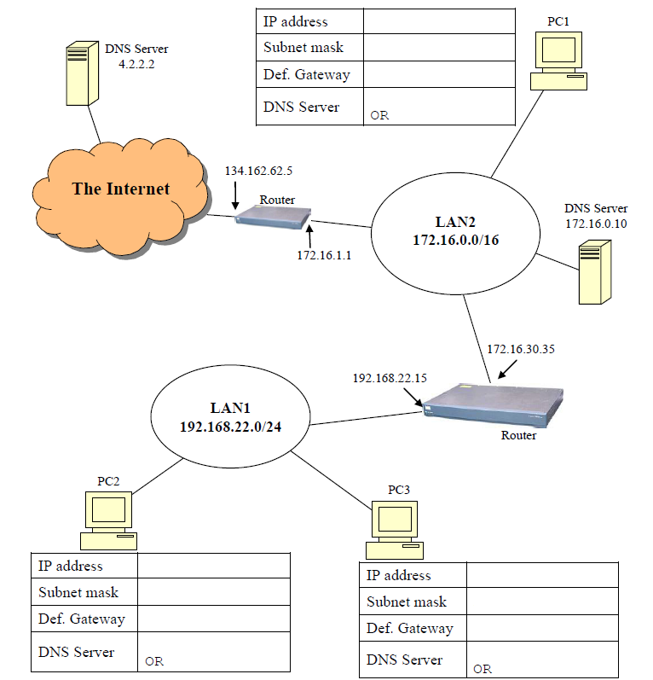

For each of the computers A, B, and C, assign an IP address, a subnet mask, and a default gateway.

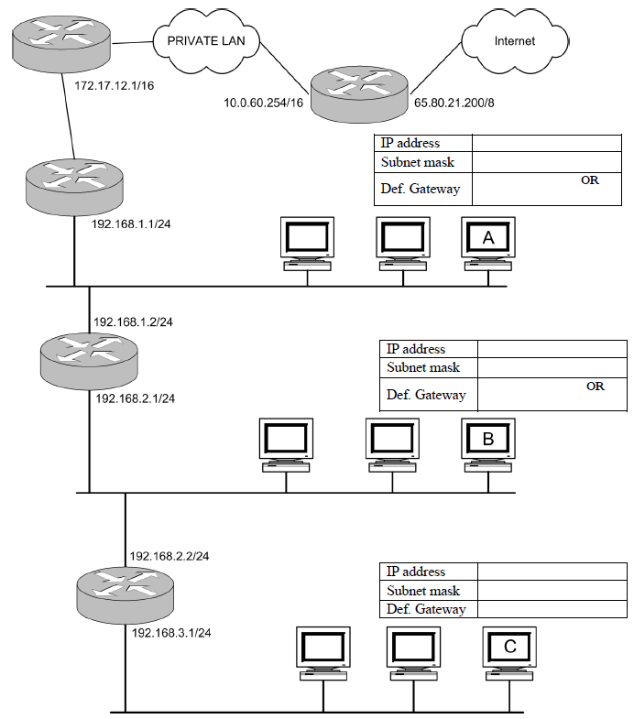

For each of the computers A, B, and C, assign an IP address, a subnet mask, and a default gateway.

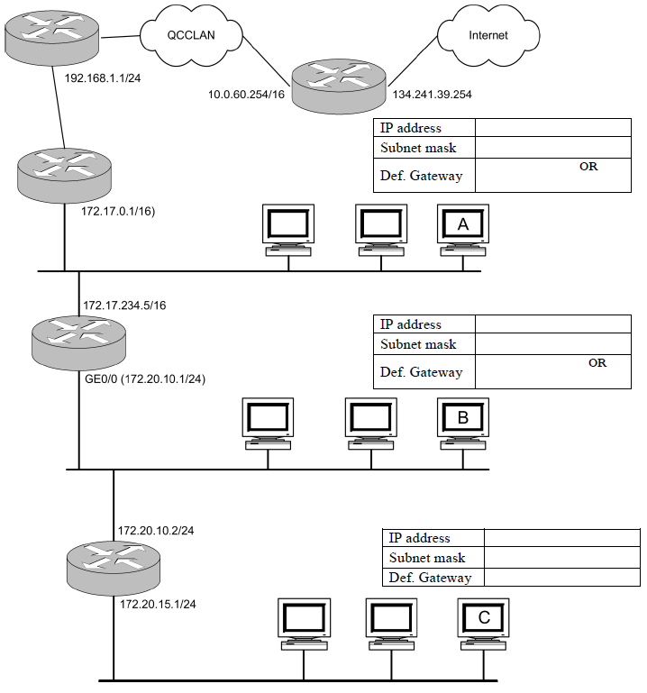

For each of the computers A, B, C, D, and E assign an IP address, a subnet mask, and a default gateway.

